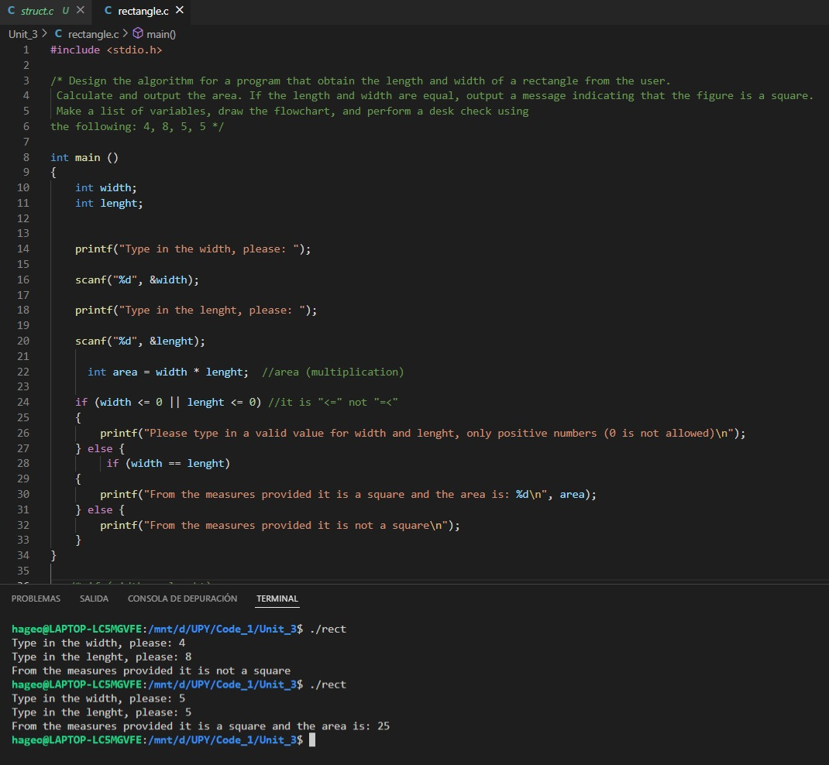Flowchart for the area of a square, it also recognizes when it is a rectangle but still prints out the area of it, it does not accept values that are below zero or equal to zero, for obvious reasons

And here we have the desk test with: 4,8 and 5,5